Agent-based model
Deliverable Number: D3.3

31 October 2026 | Final Version
Nicolas Payette
Public

Document information

Grant Agreement | 101157456
Project Acronym | SURIMI
Project Title | Integration of innovative and reliable socio-ecological models and user-driven solutions into the Digital Twin Ocean, to facilitate what-if scenarios and decision support, under a co-creation approach.
Deliverable Number | D3.3
Work Package Number | WP3
Deliverable Title | Agent-based model
Lead Partner | UOXF
Author(s) | Nicolas Payette
Due Date | 31 October 2026
Submission Date | 30 October 2026
Dissemination Level | Public
Type of Deliverable | Other

Version | Summary of Changes
Version 0 | Initial version
Version 1 | Addition of figures
Final Version | Transferred to doc template

SUMMARY
Entry | Detail
Programming language | Java 25
Nr of Kubernetes pods | 1
GitHub repos | https://github.com/poseidon-fisheries/POSEIDON (core platform), https://github.com/SURIMI-Project/SURIMI-POSEIDON (SURIMI service), https://github.com/SURIMI-Project/SURIMI-POSEIDON_inputs (North-Western Mediterranean scenario data)
Licence | GPL-3.0 (POSEIDON and SURIMI-POSEIDON), CC BY 4.0 (North-Western Mediterranean scenario data)

POSEIDON is the agent-based model of the SURIMI toolbox. It represents fishing fleets as individual vessels that decide where to fish, adapt to changes in biomass and regulations, and report their catches, sales and fishing activity to the other SURIMI models. For SURIMI, POSEIDON was rebuilt as a modular platform that can run either on its own or as one component of the SURIMI model ensemble, driven by the SURIMI Controller. This document describes the model's purpose (§1), how it exchanges information with the other models over the course of a simulation (§2), and its inputs (§3) and outputs (§4), using the North-Western Mediterranean scenario, which covers the Spanish bottom trawl and purse-seine fleets, as the example.

CONTENTS
Document information 1
SUMMARY 2
1. Model purpose 4
2. Process overview and scheduling diagrams 5
3. Inputs 8
3.1 POSEIDON configuration inputs 8
3.2 Inputs received as SURIMI messages 9
3.2.1 InitialiseSimulation 9
3.2.2 UpdateRegulations 10
3.2.3 UpdateSpeciesPrices 11
3.2.4 UpdateBiomass 11
3.2.5 Control messages 12
4. Outputs 12
4.1 Outputs provided as SURIMI messages 12
4.1.1 GetCatchDisposition 13
4.1.2 GetSales 13
4.1.3 GetFishingActivity 13
4.2 Other potential POSEIDON outputs 13

1. Model purpose
As the agent-based model (ABM) of SURIMI, POSEIDON's purpose is to represent some of a case study's fishing fleets as individual vessels, so that the model captures how fishers adapt to their circumstances instead of assuming a fixed distribution of fishing effort. Vessels differ in their characteristics, such as size, gear and home port, are subject to the regulations that apply to them, and decide individually where to fish. In the North-Western Mediterranean scenario, a vessel remembers what it caught at each fishing ground it has fished, as well as the catches reported to it by a few partner vessels from the same port with the same gear. A vessel setting out on a trip either explores a fishing ground near the best one it knows or, more often, goes to the ground it expects to be the most profitable: the value of the catch it expects there, at the prices of its home port's market, minus the cost of the time needed to sail there and back. Fishing effort therefore moves as biomass, closures and regulations change, which is the kind of response that management strategy evaluation needs to capture.
POSEIDON was developed at the University of Oxford as a general platform for exploring how fishers adapt to their environment and to management. Its vessels follow simple adaptive decision rules rather than perfectly rational optimisation (Bailey et al., 2019; Carrella et al., 2019). It has since been applied to several fisheries. For the US West Coast groundfish fishery, simple adaptive rules were shown to describe fishing behaviour better than perfect rationality (Carrella et al., 2020). It was also applied to the deep-water snapper fishery of Indonesia, supported by a survey of fishers' decision-making (Madsen et al., 2023). For the hairtail troll fishery of the Bungo Channel in Japan, it was combined with rejection sampling to deal with limited data (Carrella et al., 2024). For the tropical tuna purse-seine fishery of the Eastern Pacific Ocean, it was used with the Inter-American Tropical Tuna Commission (IATTC) to evaluate limits on the number of fish aggregating devices (FADs) (Payette et al., 2023; Vert-Pre et al., 2024). That model has since been adapted to the Atlantic tropical tuna fishery for the International Commission for the Conservation of Atlantic Tunas (ICCAT) (Vert-Pre et al., 2025).
POSEIDON grew through a series of applied projects, each with its own deadlines and requirements, and each adding the components and scenarios it needed. It was designed as a self-contained program that simulated the whole fishery, biology included. SURIMI requires POSEIDON to also operate as one component among several: driven step by step by the SURIMI Controller, receiving biomass from an ecosystem model and prices from a market model instead of computing them, and reporting its results in the terms and units agreed by all models. Because these requirements touch every part of the model, POSEIDON has been rebuilt from the ground up, carrying over its concepts and the lessons of its past applications. Its founding idea of assembling scenarios from interchangeable components such as vessels, gears, behaviours, regulations, biology and markets, now runs through the whole code. A new case study therefore needs mostly configuration and data, and new code only for mechanisms POSEIDON lacks, such as the TAC regulations written for SURIMI, which other scenarios can then reuse. POSEIDON can still run on its own, with its own biology and markets, as in the example scenario of a single-species snapper fishery included in the repository. The previous code remains available in the legacy branch of the POSEIDON repository.
In practice, the agent-based model that constitutes this deliverable consists of three distinct but closely coupled parts:
- Core POSEIDON (poseidon-fisheries/POSEIDON), the modular platform for building agent-based models of fisheries. It is written in Java and builds on the MASON agent-based simulation library.
- SURIMI-POSEIDON (SURIMI-Project/SURIMI-POSEIDON), the service that connects core POSEIDON to the other SURIMI models. Most of it implements the SURIMI protocol, but it also contains SURIMI-specific model components, such as the total allowable catch (TAC) regulations used for management strategy evaluation (MSE).
- The North-Western Mediterranean scenario, POSEIDON's part of the case study built to demonstrate SURIMI's capabilities. It consists of a scenario definition, generated from Java code and stored in SURIMI-POSEIDON as a readable YAML file, and the data files it uses (§3.1), which have their own repository (SURIMI-Project/SURIMI-POSEIDON_inputs).

Because POSEIDON is modular, its inputs and outputs depend on the components a scenario uses. The SURIMI messages it exchanges are fixed by the protocol, but its configuration inputs and the way it uses the messages vary from one scenario to another. This document therefore takes the North-Western Mediterranean scenario as representative of a POSEIDON scenario used in SURIMI.
The technical documentation of core POSEIDON is its JavaDoc, which describes every component a POSEIDON scenario can use. SURIMI-POSEIDON has its own JavaDoc. Its README explains how to run the North-Western Mediterranean scenario on its own, with a graphical interface, and how to deploy SURIMI-POSEIDON as a SURIMI service from its Docker image.

2. Process overview and scheduling diagrams
The data flow diagram (Figure 1) shows where POSEIDON sits among the SURIMI models and what information it exchanges with them. POSEIDON represents some of the case study's fleets as individual vessels. Ecopath with Ecosim (EwE) represents the ecosystem, the environment and all the other fleets. The diagram shows the main information flows rather than the exact message routes. All exchanges pass through the SURIMI Controller; POSEIDON’s catches reach CMSY++ and the Fisheries Authority through EwE’s combined totals. Fishing activity is collected by the Controller for experiment outputs.
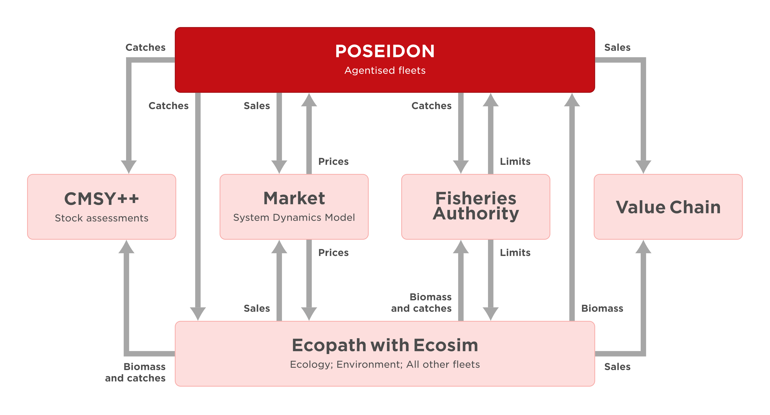
Figure 1. Position of POSEIDON within the SURIMI framework for the North-Western Mediterranean case.
The sequence diagram (Figure 2) shows the order of the exchanges between the Controller and POSEIDON. An experiment submitted through the GUI can run many simulations in parallel, typically to compare management strategies in an MSE. Because POSEIDON is stochastic, repeated runs of the same scenario also quantify variability due to the model’s stochastic behaviour. In each simulation, POSEIDON receives new regulations at the start of every year. Every month, it then receives updated prices and biomass, simulates the month, and reports its catches, sales and fishing activity. The biomass and catches marked "intermediate" are exchanged between EwE and POSEIDON alone: POSEIDON fishes from the biomass EwE has just computed, and its catches go back to EwE, which removes them from the biomass when it simulates the next month. The Fisheries Authority and CMSY++ receive EwE's totals instead, which include the catches of all fleets. Sections 3 and 4 describe each message.
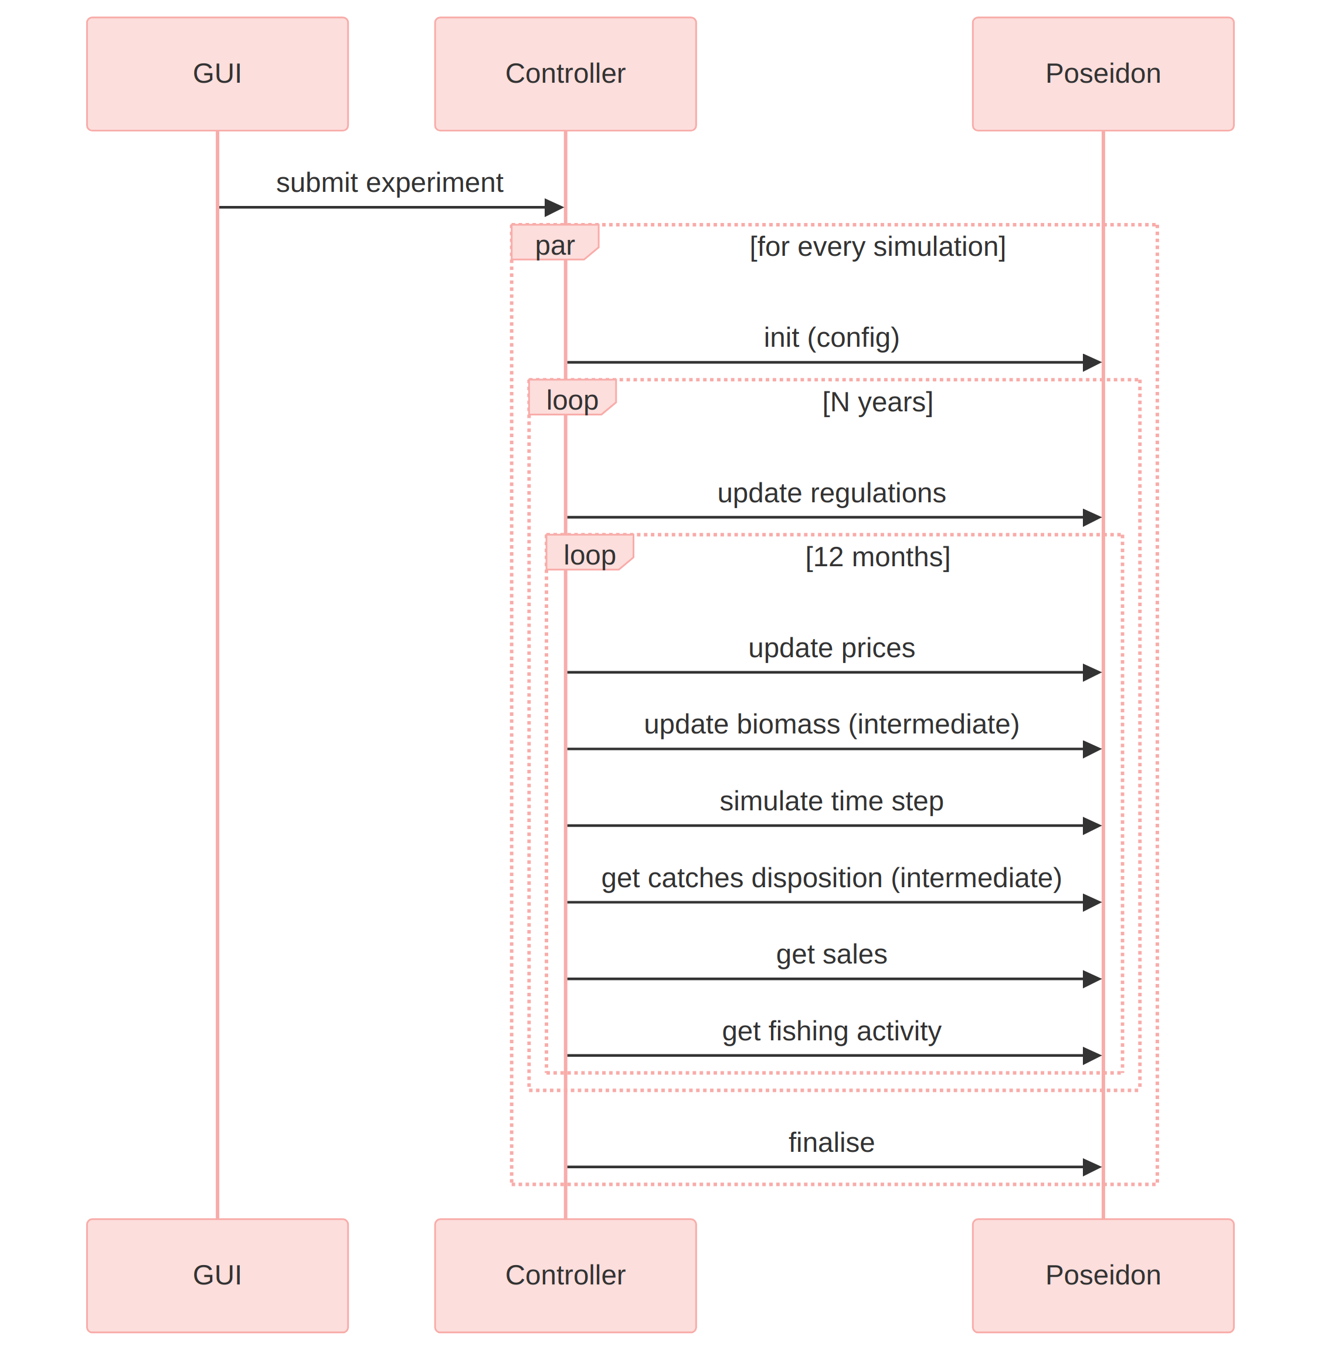
Figure 2. Communication flow between the SURIMI Controller and POSEIDON during a simulation.
Within each monthly step, POSEIDON simulates the fishery in continuous time, and each vessel repeats the same trip cycle. A vessel in its home port waits until it may leave: on a fishing day, at its fleet's usual departure time (in the evening for purse seiners, in the morning for bottom trawlers), if it has not already left that day, and only if its fleet segment has not exhausted any of its quotas. It then chooses a fishing ground as described in §1, among the cells where the regulations in force allow it to fish and that it can reach, fish and return from within its fleet's trip duration. It travels there along a path through the model grid and performs a fishing operation, a set or a tow. Its catch depends on the biomass in that cell and gear- and species-specific catchability, and is removed from the cell’s biomass. Its discards are returned to the sea dead. The vessel records that catch and reports it to its partners, which updates what they all know about the fishing grounds. It then chooses its next fishing ground in the same way, except that it explores around where it is rather than around the best ground it knows, and leaves out the cells it has already fished during the trip. It goes on fishing until no ground is left that it can reach, fish and still return from in time, then sails back to port, lands its catch and sells it at the port's market.
Once a day, the catches of each fleet segment are added up and compared with its quotas: when a quota is exhausted, the segment's vessels stay in port until the end of the quota period, and those at sea choose no further fishing grounds. The catches, sales and fishing activity that POSEIDON reports to the Controller (§4.1) cover all the trips made during the step.

3. Inputs

3.1 POSEIDON configuration inputs
Everything that defines a POSEIDON scenario, apart from the dynamic inputs of §3.2, is read from the scenario's YAML file when InitialiseSimulation creates the simulation. In the North-Western Mediterranean scenario, the YAML sets the behavioural and regulatory parameters, such as vessel speeds, departure days and times, maximum trip durations and the depths at which each gear may fish. It also points to the data files listed below, in the northwestern_med folder. A data preprocessing pipeline, written in R, produces these files from the sources listed.
The scenario represents the Spanish bottom trawlers (OTB) and purse seiners (PS) of the North-Western Mediterranean, from Cartagena to the French border, with every vessel in these fleets modelled individually. Between 2013 and 2024, 448 to 491 trawlers and 109 to 144 purse seiners were active at any one time, based in 36 ports. The modelled sea area, on a grid of 1/12° cells, covers about 55,000 km², of which about 39,000 km² lie outside the French exclusive economic zone, before other fishing restrictions are applied. The scenario's data cover 2013 to 2024. The start and length of a SURIMI simulation are set by the Controller (§3.2.1).
Input | Content | Source
Geography
bathymetry_grid.​asc | Depth of each cell of the model grid (1/12° resolution). | EwE model grid; GEBCO land elevations
exclusion_grid.​asc | Cells outside the modelled area. | EwE model
ports.​csv | Ports where the modelled vessels are based, land and sell. | EMODnet first sales
Fleets
fleet_register.​csv | Each vessel's characteristics (length, gear, home port, etc.) and the history of its registration, which determines when it is active. | EU Fleet Register
operating_costs.​csv | Hourly and daily operating costs by country, year, vessel length class and gear. | STECF Annual Economic Report
Species
species.​csv | Species and life stages modelled. | FAO ASFIS, EwE model
discard_ratios.​csv | Fraction of the catch discarded, by species, life stage and gear. | EwE model
Regulations
mpa_grids.​nc, mpa_months.​csv, mpa_fleet_restrictions.​csv | Marine protected areas, the months in which they are closed and the fleets they apply to. | EwE model
port_closures.​csv | Temporary cessations of activity, by port and gear. | Compiled by ICM-CSIC from Spanish and Catalan regulations
habitat_grids.​nc | Rock, Posidonia oceanica and Cymodocea habitats, where fishing is forbidden. | EwE model
french_eez.​asc | French exclusive economic zone, excluded from fishing in this scenario. | Marine Regions World EEZ
Calibration (standalone runs only)
biomass_grids.​nc | Yearly spatial distribution of each species' biomass, 2013–2024, standing in for the biomass otherwise provided by EwE. | EwE model outputs
prices.​csv | Monthly first-sale prices by port, species and category, 2013–2024 (2013–2014 use 2015 prices), replacing the market model’s prices in standalone runs. | EMODnet first sales
target_landings.​csv | Yearly landings by gear, species and life stage, to which the simulated landings are fitted. | STECF FDI, split by life stage using the EwE model

The last three inputs serve to calibrate the model's parameters, such as the catchability of each gear for each species and the parameters governing how vessels choose where to fish. Calibration runs POSEIDON on its own, disconnected from the other SURIMI models, so these files replace the biomass and prices it would otherwise receive through UpdateBiomass and UpdateSpeciesPrices. The calibration of the North-Western Mediterranean scenario is still in progress. The software is operational; the scenario’s quantitative results remain provisional pending calibration.

3.2 Inputs received as SURIMI messages
POSEIDON receives all its dynamic inputs from the SURIMI Controller over gRPC (FisheryService, proto package surimi.v1). The messages below are in the order in which they occur during an experiment.

3.2.1 InitialiseSimulation
Sent once per simulation, before anything else (request, response). It creates a POSEIDON simulation instance from one of the scenarios bundled with the service (see §3.1). It also delivers the simulation contract (Simulation), which lists the items (species, markets, fleet segments, etc.) that the models in the ensemble agree to exchange information about, and the units they use. POSEIDON may model more than the contract lists, for example extra species or fleets, but it only reports on items in the contract.
Field | Meaning | Use in POSEIDON
simulation_id | Identifies this simulation. Many simulations run in parallel in one experiment. | Key under which the simulation instance is stored.
scenario_name | Name of the scenario, e.g. northwestern_med. | Selects the bundled scenario to run.
simulation.​start_date_time | Start of the simulation. | Overrides the scenario's start date.
simulation.​time_step | Length of one step, e.g. one month (P1M). | Every SimulateStep advances the simulation by this period.
simulation.​standards.​measurements | Units used in subsequent messages. | A mass unit is required. All biomass, catch, sales and quota quantities, as well as prices (per unit of mass), are exchanged in that unit.
simulation.​items.​species, .​markets, .​price_categories | Species (with life stage), markets and price categories in the contract. | Catches and sales are only reported for these.
simulation.​items.​fleet_segments | Fleet segments, defined by gear, vessel length class, scale, country and model. Unset fields match any value. | POSEIDON only considers the segments assigned to it, which must not overlap. Each vessel's catches and sales are reported under the segment that covers it. Vessels outside all segments are not reported.
simulation.​geography | Region, resolution and raster conventions. | POSEIDON only checks that raster cells are referenced by their centroid.
climate_scenario | Climate scenario identifier, e.g. RCP_4.​5. | Not used directly: POSEIDON does not model climate itself, and climate effects reach it through the biomass updates (UpdateBiomass).

The remaining fields (case study name, end dates, currencies and the list of climate scenarios) are not used by POSEIDON. The response only echoes the simulation ID. Requests that violate the constraints above are rejected with an error.

3.2.2 UpdateRegulations
Sent at the start of each management period, typically each year, with the total allowable catches (TACs) decided by the Fisheries Authority for that period (request, response). TACs are currently the only kind of regulation exchanged in SURIMI.
Field | Meaning | Use in POSEIDON
start_date_time, end_date_time | Period the regulations apply to. | Each TAC applies to catches made during this period.
regulations_summary.​total_allowable_catches | List of TACs, each for one species and one fleet segment, in the contract's mass unit. | Each TAC becomes a quota on the vessels covered by the fleet segment. TACs for fleets simulated by other models are ignored. A TAC for a species without a life stage covers all its life stages.

POSEIDON tallies each fleet segment's catches against its quotas as the simulation runs (daily, in the North-Western Mediterranean scenario). Everything caught counts, discards included. When a daily check detects that any one of a segment’s quotas is exhausted, fishing closes for the whole segment until the end of the period, even if its other quotas are not used up. The quotas do not distinguish between areas or stocks. The resulting closures are reported back through GetFishingActivity (§4.1.3).

3.2.3 UpdateSpeciesPrices
Sent every step, before the step is simulated, with prices computed by the market model (request, response).
Field | Meaning | Use in POSEIDON
species_price_summary.​species_prices | List of prices, each for one species, price category (e.g. "Fresh - Whole") and market (a port), in a given currency per unit of the contract's mass unit. | Sets the price at which vessels sell that species and category when landing in that port. Prices for markets that are not in the scenario are ignored. A price for a species without a life stage applies to all its life stages.

Prices stay in effect until replaced by a later update. They determine the revenue vessels get from their landings, and therefore what they report through GetSales (§4.1.2).

3.2.4 UpdateBiomass
Sent every step, before the step is simulated, with the spatial distribution of biomass computed by Ecopath with Ecosim (EwE) (request, response). This is how POSEIDON's fleets interact with the ecosystem: EwE models the ecology and the environment, including the effects of climate and of all fleets' catches, and POSEIDON's vessels fish from the biomass it provides.
Field | Meaning | Use in POSEIDON
date_time | Moment the biomass is computed for. | Must match the current simulation time.
biomass_summary.​biomass_grids | One grid per species, giving the biomass in each cell (identified by the coordinates of its centre), in the contract's mass unit. | Replaces the biomass of that species in the corresponding cells of POSEIDON's grid. Species that POSEIDON does not model are ignored.

During the step, vessels' catches deplete the biomass where they fish. The next update replaces it with EwE's new values, which take into account the catches POSEIDON reported through GetCatchDisposition (§4.1.1).

3.2.5 Control messages
These messages control the simulation rather than supply fishery inputs.

3.2.5.1 SimulateStep
Sent once per step, after the inputs for that step have been received. POSEIDON advances the simulation by one time step (as set in InitialiseSimulation), during which vessels go through the trip cycle described in §2. The request carries the current simulation time, which must match POSEIDON's own.

3.2.5.2 FinaliseSimulation
Sent once at the end of a simulation. POSEIDON ends the simulation and releases it.

3.2.5.3 CancelSimulation
Sent if a simulation is cancelled before its end, e.g. when the user aborts the experiment. POSEIDON discards the simulation without finalising it.

3.2.5.4 GetProtocolVersion
Can be sent at any time, independently of any simulation. POSEIDON returns the version of the SURIMI protocol it implements, so the Controller can check that the two are compatible.

4. Outputs

4.1 Outputs provided as SURIMI messages
POSEIDON's outputs are requested by the Controller after each step and forwarded to the other models. Each request specifies a time period, normally the step just simulated, and POSEIDON reports on what happened during that period. Catch and sales masses are expressed in the contract's mass unit, and, as explained in §3.2.1, only items in the contract are reported.

4.1.1 GetCatchDisposition
Reports the catches of POSEIDON's fleets (request, response). The catches are used by EwE to update the biomass. CMSY++ and the Fisheries Authority receive them as part of EwE's total catches, which cover all fleets.
Field | Meaning
catch_disposition_summary.​disposition_grids | One grid per fleet segment and species, giving, for each location where fish were caught, the gross catch (everything caught) and how much of it was discarded alive and dead. Landings are the gross catch minus the discards.

4.1.2 GetSales
Reports the sales of POSEIDON's fleets (request, response). The sales are used by the market model to compute prices (§3.2.3) and by the value chain model.
Field | Meaning
sales_summary.​market_sales | Sales grouped by market (port) and currency. Each sale gives, for one fleet segment, species and price category, the quantity sold and its value.

4.1.3 GetFishingActivity
Reports the fraction of time not closed by TAC exhaustion (request, response). It is not passed on to other models: the Controller aggregates it across the simulations of an experiment and includes it in the experiment's outputs.
Field | Meaning
fishing_activity_summary.​fishing_activities | For each fleet segment with TACs that apply to POSEIDON's fleets during the period (§3.2.2), the fraction of the period not closed by TAC exhaustion: 1 if no TAC closure applied, 0 if a TAC closure applied throughout.

This measures TAC-related closures only, not other fishing restrictions or the fishing effort actually exerted.

4.2 Other potential POSEIDON outputs
The outputs of §4.1 are a deliberately narrow subset of what POSEIDON simulates: they are what the other SURIMI models need. Because every vessel is modelled individually, POSEIDON also keeps track of each vessel's trips, where and for how long it fished, what it caught, landed and sold, and what its trips cost. From these, many more outputs could be derived, for example:
- maps of fishing effort, by fleet segment or by vessel;
- revenues, costs and profits, by vessel, port or fleet segment;
- the number of active vessels and trips over time;
- how vessels redistribute their effort in response to closures and quotas.

When the model runs on its own, POSEIDON's visual interface already shows vessels moving across the map, together with the biomass and the areas closed by regulations (Figure 3). The other outputs listed above would still need to be added, either as files written during standalone runs or as new messages in the SURIMI protocol.
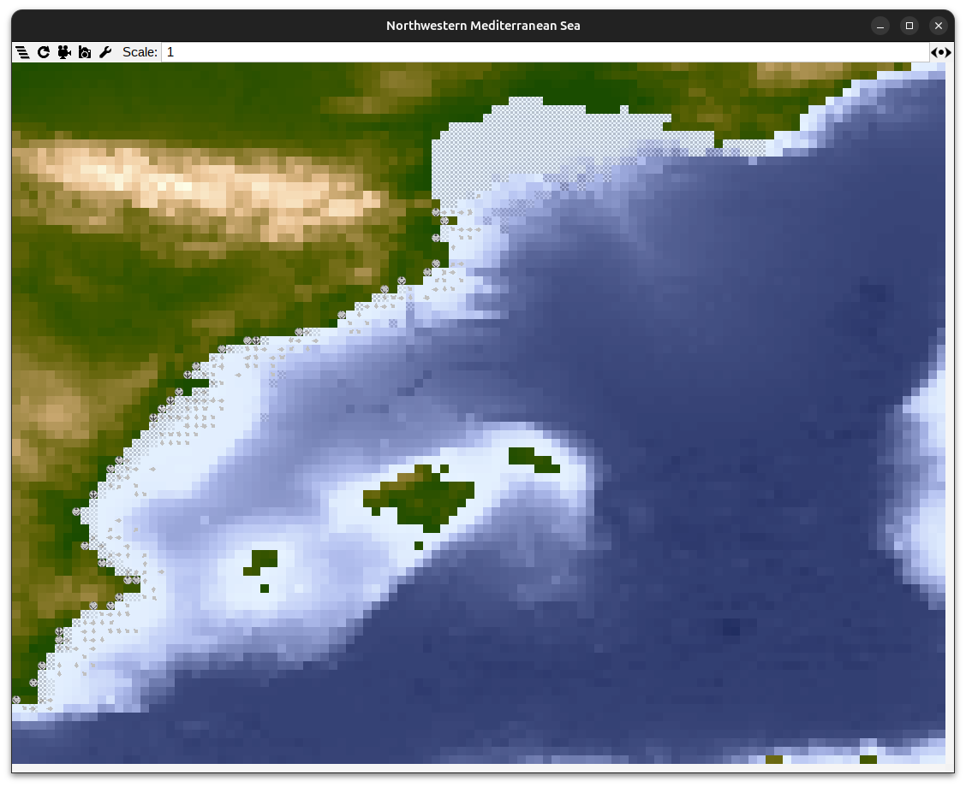
Figure 3: POSEIDON's graphical interface running the North-Western Mediterranean scenario.

Scientific Coordinator
Patrycja Antosz | paan@norceresearch.no

Project Management
Catherine Lourdes Dy | PMO-SURIMI@norceresearch.no

Press and Communications
Keegan Porter | keegan@erinn.eu
Emma Bello Gomez | emma@erinn.eu

More Information
Website | surimi-project.eu
LinkedIn | SURIMI Project
Bluesky | @surimi-project.bsky.social

